



Filmmaking for beginners 2025 by Frans Hoeben

Program per day
Monday 10 Aug 2026  11-17u  HKU  Oudenoord 700  Lokaal 321 | Getting to know each other  Assessment of everybody’s capabilities  Looking at everybody’s introduction-films  Presentation: Filmstages  Crash course découpage: principles of découpage  99 ways to tell a story, working with the five W’s  Make 10 shots of a simple action or situation like walking the stairs or getting a refreshment from a machine or enjoying a cup of coffee  What went well and what went wrong, what could be better
Tuesday 11 Aug 2026  10-17u  HKU | Crash course camera.  First film assignment in crews of about 3 persons: The encounter  A certain person in Utrecht contacts another person in some way, gets on the move and encounters the other person to exchange something special  Or he/she meets with (or finds) a certain interesting object. Something exciting develops from this encounter
Wednesday 12 Aug 2026  10-17u  HKU 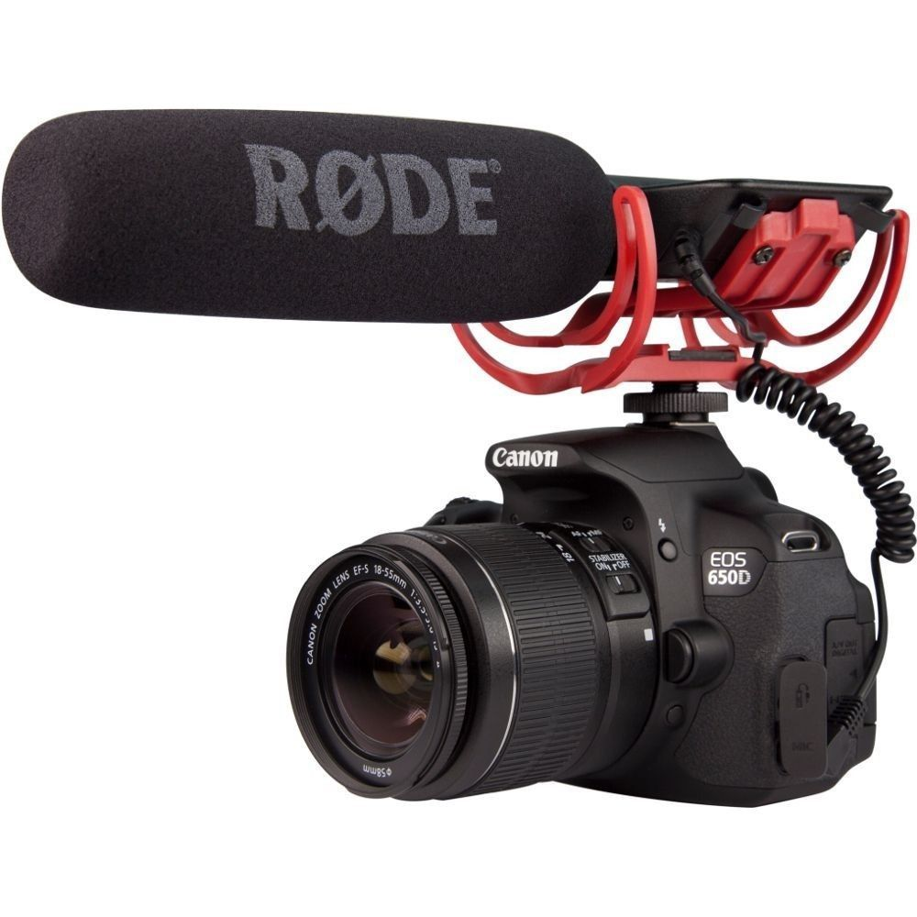 | Watching and discussing the assignments of yesterday  Crash course sound  Handling the equipment, preparation of good sound  Art of listening, art of booming, art of editing sound
Thursday 13 Aug 2026  10-17u  HKU | Second film assignment: about sound  Make a short film in which sound is very important.  Try to use your experiences of yesterday to improve your story
Friday 14 Aug 2026  10-17u  HKU | Watching and discussing the assignments of yesterday  Presentation: The secret of Hollywood  How do you write a successful story like they do in Hollywood?  Analyzing a film according to the rules of Hollywood
Saturday 15 Aug 2026 | Free
Sunday 16 Aug 2026 | Free
Monday 17 Aug 2026  10-17u  HKU  Oudenoord | Presentation: Let there be light  The power of light in film  Looking at examples and analyzing the set-up  Basic instruction three-point lighting  Creating an atmosphere with light  Balancing existing light with artificial light  Start thinking about the final film: Create your own story for a short movie: fiction or non-fiction,  News-documentary-educational-fiction-experimental
Tuesday 18 Aug 2026  10-17u | Third film assignment:  Writing and preparing the final film  (according to the secrets of Hollywood if you like)  Do research, look for locations and actors, write the script, make a storyboard, make a planning
Wednesday 19 Aug 2026  10-17u  HKU | Shoot and edit the final film  Finish the film assignments at HKU
Thursday 20 Aug 2026  10-17u  HKU | Watching and discussing all movies  Rating of everybody’s contribution  Final discussions
Friday 21 Aug 2026  10-13u  HKU Oudenoord | Evaluation of the seminar  Saying goodbye

