Course:

**Artificial Intelligence (AI), Governance and Law**

# 07.07.2025 - 11.07.2025

# Location: Lecture room 004 Janskerkhof 15A Utrecht

**Course Director:**

prof. dr. Wilco Oostwouder

[wilco.oostwouder@loyensloeff.com](mailto:wilco.oostwouder@loyensloeff.com)

**Course Assistants**

Duncan Comvalius

[duncan@comvalius.net](mailto:duncan@comvalius.net)

Maria Ishaq

[maria.ishaq@studemt.uva.nl](mailto:maria.ishaq@studemt.uva.nl)

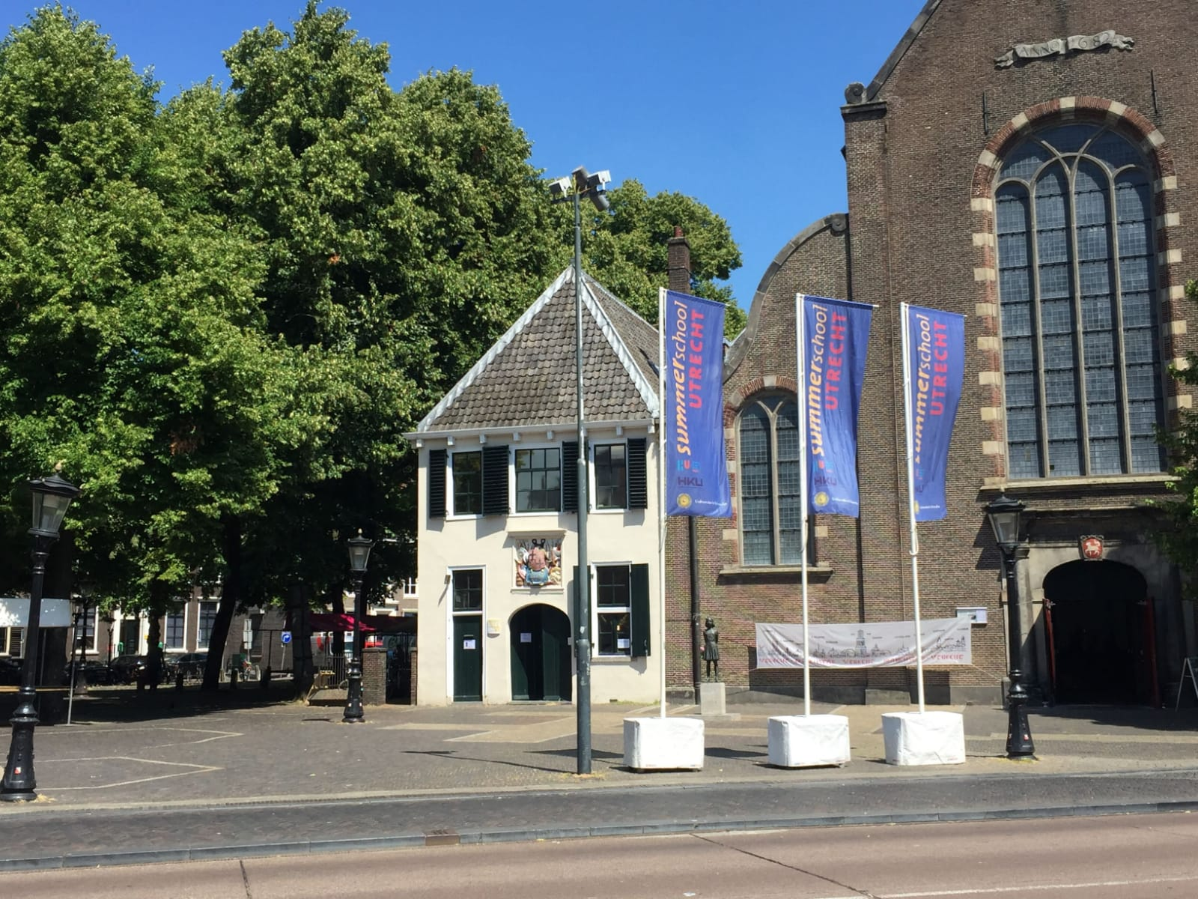

|  |  |  |
| --- | --- | --- |
| **MONDAY, 7 JULY** | | |
| **TIME** | **ACTIVITY** | **DESCRIPTION** |
| 10.00 – 10.15 | Opening/and introduction | *Prof. dr. Wilco Oostwouder*  *(Attorney at law Loyens & Loeff)* |
| 10.15-11.15 | *Lecture* | Understanding Artificial Intelligence: Core Concepts  and Technical Foundation  *Raymond Comvalius*  *(Multifocused IT*  *infrastructure specialist*  *consultant and trainer)* |
| 11.15– 11.30 | *Coffee break* | |
| 11.30 – 12.30 | Lecture | AI in Action: Key Applications Transforming Daily life  and Industries  *Raymond Comvalius* |
| 12.30 – 13.30 | *Lunch break* | |
| 13.30 – 14.30 | Lecture | The position of AI in legal  *Ingrid van de Pol - Mensing*  *(co-founder & co-CEO Uncover Legal)* |
| 14.30 – 14.45 | *Coffee break* | |
| 14.45 – 15.45 | Work-shop | An exercise in structuring case files, generating timelines and summaries and conducting comprehensive document searches with AI.  *Ingrid van de Pol – Mensing* |
| 15.45 – 16.00 | Instruction to the library/exam/presentations | |

|  |  |  |
| --- | --- | --- |
| **TUESDAY, 8 JULY** | | |
| **TIME** | **ACTIVITY** | **DESCRIPTION** |
| 10.00 – 11.00 | Lecture | Limitations set by the EU AI Act. Part I  Not enough, enough or too much to protect citizens  and businesses?  *Marleen Huisman and Nicole Wolters Ruckert*  *(Attorneys at law A&O Shearman)* |
| 11.15 – 11.30 | *Coffee break* | |
| 11.30– 12.30 | Lecture | Limitations set by the EU AI Act. Part II  Not enough, enough or too much to protect citizens  and businesses?  *Marleen Huisman and Nicole Wolters Ruckert*  *(Attorneys at law A&O Shearman)* |
| 12.30 – 13.30 | *Lunch break* |  |
| 13.30 – 14.30 | AI and privacy  Lecture *Marleen Huisman and Nicole Wolters Ruckert*  *(Attorneys at law A&O Shearman)* | |
| 14.30 – 15.30 | Lecture | AI and copyright  *Marleen van Putten*  *(Attorney at law A&O Shearman)* |
| 15.30 – 17.00 | Preparations for the exam/presentations | |

|  |  |  |
| --- | --- | --- |
| **WEDNESDAY, 9 JULY** | | |
| **TIME** | **ACTIVITY** | **DESCRIPTION** |
| 10.00 – 11.00 | Lecture | Governance of AI systems, liability and contracts  *Yannick Geryszewski*  *(Attorney at law Loyens & Loeff)* |
| 11.00 – 11.15 | *Coffee break* | |
| 11.15 – 12.30 | Lecture | AI, Mergers & Acquisitions and Corporate Governance    *Dr. Wessel Wijtvliet*  *(AI and Legal Tech at Loyens & Loeff and Research fellow*  *at KU Leuven)*  *Prof. dr. Wilco Oostwouder*  *(Attorney at law Loyens & Loeff)* |
| 12.30– 17.30 | Preparation for the exam/presentations | |

|  |  |  |
| --- | --- | --- |
| **THURSDAY, 10 JULY** | | |
|  | | |
| **TIME** | **ACTIVITY** | **DESCRIPTION** |
| 11.00 – 12.15 | Lecture | AI and ethical principles like explainability, fairness  and accountability.  *O.A. (Ola) Al Khatib*  *(PhD Candidate Law, Economics and Governance*  *Utrecht University School of Law)* |
| 12.15 – 13.15 | *Lunch break* | |
| 13.15 – 14.15 | Lecture | AI and Health  *Arjan Groen*  *(Chief Technology Officer Medendo)* |
| 14.15 – 14.30 | *Tea break* | |
| 14.30 – 15,30 | Lecture The impact of AI on jobs and the economy  *Wouter-Bas van der Vegt*  *(Global Data Protection Officer Randstad)* | |
| 15.30 – 17.30 | Preparation for the exam/presentations | |

|  |  |  |
| --- | --- | --- |
| **FRIDAY, 11 JULY** | | |
| **TIME** | **ACTIVITY** | **DESCRIPTION** |
| 10.00 – 11.00 | Lecture | Implications of the use of AI in public governance  *Dr. Anneke Zuiderwijk*  *(Associate professor at the Faculty of Technology, Policy*  *Management, Delft University of Technology)* |
| 11.00 – 11.15 | *Coffee break* | |
| 11.15 – 12.30 | Lecture | AI in Cybersecurity: Defending Against Evolving Threats  *Raymond Comvalius*  *(Multifocused IT*  *infrastructure specialist*  *consultant and trainer)*  *Kirill Ryabtsev*  *(Paralegal and member of the Privacy and Cybersecurity*  *team of Loyens & Loeff and PhD Candidate in*  *competition law at Vrije Universiteit Amsterdam)* |
| 12.30 – 13.30 | *Lunch break* | |
| 13.30–15.00 | The exam/presentations Jury for the group presentations:  *Dr. ing. Yvette Roman*  *(AI Governance Officer at Utrecht University)*  *Raymond Comvalius*  *Kirill Ryabtsev*  *Prof. dr. Wilco Oostwouder* | |

**Artificial Intelligence (AI), governance and law**

**The principal team of lecturers**



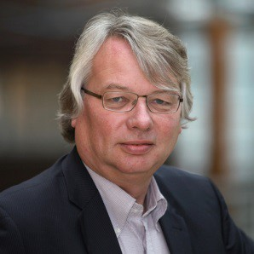

**Wilco Oostwouder**

*Attorney at law*

*1997-present*

*Professor*

*Corporate Finance Law*

*2002-2021*

