Filmmaking for beginners by Frans Hoeben

Program per day

Monday 8 Aug 2022  10-17u  HKU  Nieuwe Kade | Getting to know each other  Assessment of everybody’s capabilities  Looking at everybody’s introduction-films  Presentation: Filmstages  Crash course decoupage: principles of découpage  99 ways to tell a story, working with the five W’s  Make 10 shots of a simple action or situation like walking the stairs or getting a refreshment from a machine or enjoying a cup of coffee.  What went well and what went wrong, what could be better.
Tuesday 9 Aug 2022  10-17u  HKU  Nieuwe Kade | Crash course camera.  First film assignment in 5 crews of about 3 persons: The encounter.  A certain person in Utrecht contacts another person in some way, gets on the move and encounters the other person to exchange something special.  Or he/she meets with (or finds) a certain interesting object. Something exciting develops from this encounter.
Wednesday 10 Aug 2022  10-17u  HKU  Nieuwe Kade  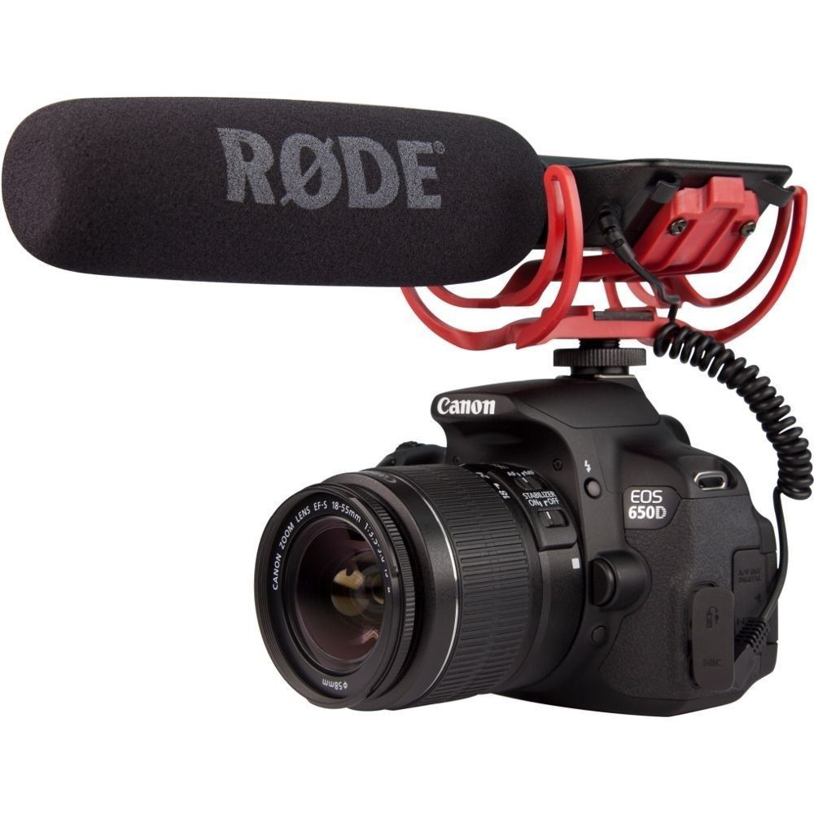 | Watching and discussing the assignments of yesterday  Crash course sound  Handling the equipment, preparation of good sound.  Art of listening, art of booming, art of editing sound.
Thursday 11 Aug 2022  HKU  Nieuwe Kade | Second film assignment: sound  Make a short film in which sound is very important.  Try to use your experiences of yesterday to improve your story
Friday 12 Aug 2022  10-17u  HKU  Nieuwe Kade | Watching and discussing the assignments of yesterday  Presentation: The secret of Hollywood  How do you write a successful story like they do in Hollywood?  Analyzing “The good shepherd” according to the rules of Hollywood.
Saturday 13 Aug 2022 | Visit the Filmmuseum in Amsterdam if you like
Sunday 14 Aug 2022 | Free
Monday 15 Aug 2022  10-17u  HKU  Nieuwe Kade  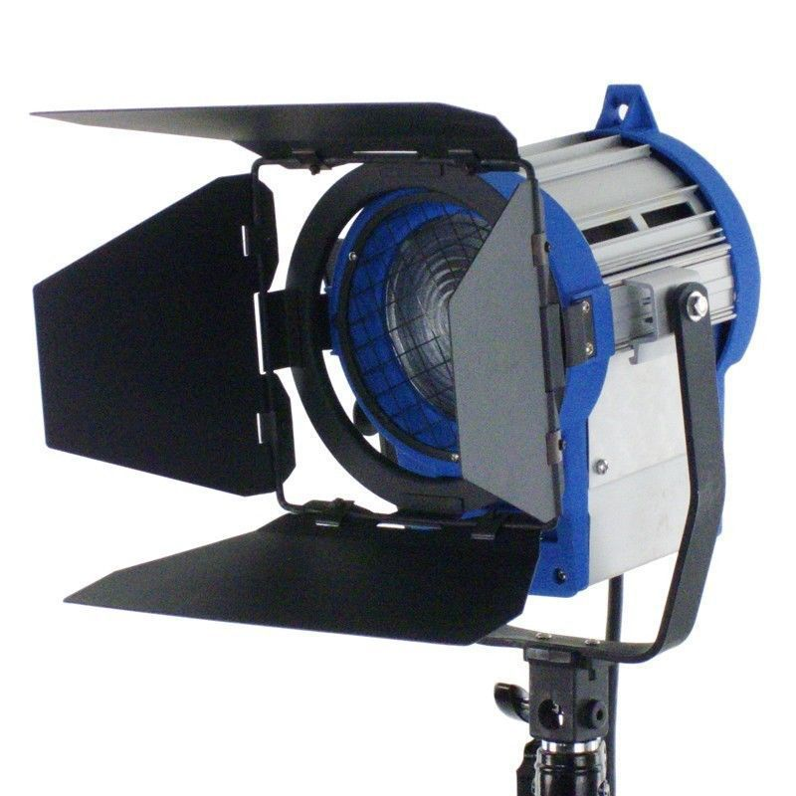 | Presentation: Let there be light  What is the power of light in film. Looking at examples and analyzing the set-up.  Practicing light in the studio.  Basic instruction three-point lighting  Creating an atmosphere with light  Balancing existing light with artificial light  Start thinking about the final film: Create your own story for a short movie: fiction or non-fiction,  News-documentary-educational-fiction-experimental
Tuesday 16 Aug 2022  Nieuwe Kade | Third film assignment:  Writing and shooting the final film  (according to the secrets of Hollywood if you like).  Do research, look for locations and actors, write the script, make a storyboard, make a planning.
Wednesday 17 Aug 2022  10-17u  HKU  Nieuwe kade | Shoot and edit the final film.  Finish the film assignments at HKU
Thursday 18 Aug 2022  10-17u  HKU  Nieuwe Kade | Watching and discussing all movies  Rating of everybody’s contribution  Final discussions
Friday 19 Aug 2022  10-13u  HKU Nieuwe Kade | Evaluation of the seminar  Saying goodbeye

